**Course Project - SAS Custom Graphs**

Shaun Pritchard

Rasmussen College

QMB4200

Terry Brookhouser

November 5, 2020

**Course Project - SAS Custom Graphs**

SAS graphs using PROC SGPLOT

**Code:**

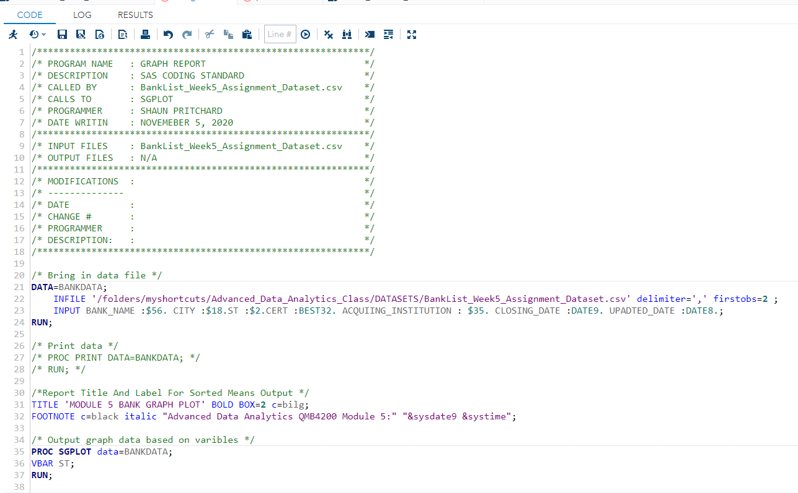

**Output:**

